**Use Case Specification**

**MoonEyes: Case Management System for Metro Detective Agency**

Senior Design I Summer 2023

BY: Kylie Callison, Erika Valle-Baird, Kendall Gresek, Pamela Shahu

Table of Contents

**1.0 Introduction 3**

1.1 Goals and objectives 3

1.2 Statement of scope 3

1.3 Software context 4

1.4 Major constraints 5

**2.0 Usage scenario 6**

2.1 User profiles 6

2.2 User stories 6

2.3 Special usage considerations 7

**4.0 Functional Model and Description 8**

4.1 Description for Function 8

4.1.1 Use case name 8

4.1.2 Actors 9

4.1.3 Preconditions 9

4.1.4 Triggers 10

4.1.5 Scenario Description 11

4.1.6 Post Conditions 13

4.1.6 Exceptions 15

4.3 Use Case Diagrams 17

**8.0 Appendices 18**

8.1 System traceability matrix 18

8.2 Product Strategies 18

8.3 Analysis metrics to be used 19

8.4 Supplementary information (as required) 20

# 1.0 Introduction

## 1.1 Goals and objectives

Our senior design project is MoonEyes: a case management system for a private detective agency. The main purpose of this project is to create a process that allows agents from Metro Detective Agency to submit and track case information(including client, subject and agent details). These exact details are specified in 1.2 Statement of Scope. Overall, the main goals and objectives of MoonEyes are as follows:

* To provide a searchable database of all case information
* To improve organization and centralize case and client details
* To improve information exchange between agents
* To increase efficiency when searching for case details
* To ensure that all data is kept secure
* To provide new marketing functionally via mass email

Additionally, the goal of this use case document is to serve as a guide when we begin developing the system. Referencing this document will help us keep track of the product requirements and user stories throughout the development timeline. This document will also allow our development team and the client to assess the quality of our finished product and ensure we have met all previously established requirements.

## 1.2 Statement of scope

As mentioned previously, this software is to serve as a case management system for agents within the Metro Detective Agency.

The following requirements were given to us for MoonEyes:

* A way in which agents can log in with credentials
* A way in which agents can remotely access the system
* A way in which an agent can enter information about a client, case, subject or agent into a database.
* Ability to search for any parameter within the database
* A way in which data that was previously entered into the database can be clearly viewed
* A way in which agents can view recent submissions or changes
* A way in which an admin user can view audit logs
* A way in which PDF reports can be generated to contain specific case/client/subject information
* A way in which a mass email can be generated and sent out to a subset of clients

**Database Creation**

In order to accommodate the requirements for client, case, agent and subject tracking, a database will need to be created. Specific details that need to be tracked for each table are described below. Furthermore, this is also the information that agents should be allowed to enter in forms and be stored in the database to search. These are additional requirements that specify the type of information that will be submitted within the database and also the parameters for the search functionality.

* **Client Tracking**

Client name, address, phone number, attorney information,and additional notes.

* **Case Tracking**

Case numbers, Purpose, date, reports, photos/videos, and additional notes.

* **Subject Tracking**

Subject name, associates, phone number, place of work, vehicle information (license plate number, type of car), lawyer information, locations visited, repeated locations, background reports, photos/videos, and any other additional notes.

* **Agent Tracking**

Badge number and case numbers.

## 1.3 Software context

**Deployment**

For this software to become accessible to agents with remote access, we will need to eventually deploy onto a cloud-based web hosting service such as Amazon EC2 or Azure. We must make sure all developments are compatible with these services. Additionally, we must ensure that any other services we might use, such as the database platform (MySQL) are compatible with the hosting service as well. Also, it is likely that users will need to be able to use the system simultaneously. Currently, we do not believe many people will have access to the system at once but expanding the amount of users could cause issues which we need to address during development.

**Security**

Because this system will likely be storing personal information about clients. Subjects and agents, security is an important consideration that needs to be integrated into the design

## 

## 1.4 Major constraints

**Funding**

As mentioned, we will need to deploy MoonEyes on a cloud-based hosting service. This means it will cost anywhere from $10-50/month for our client.

**Time**

Because this project is for our senior design project we have a strict eight-month development timeline. It is possible that we might want to make improvements or add additional features down the road that are incompatible with the amount of time left. Additionally, all members of the team will also be balancing class and work responsibilities along with our project.

**Experience**

Because our group consists of students with limited professional development experience, we may have to do more independent and team research than a typical development team.

.

# 2.0 Usage scenario

## 2.1 User profiles

**Users**:

Admin

User

System

**There will be two levels of users:**

Full Control:

Administrator

Read Only:

General Public

## 2.2 User stories

**User Story**: As a user, I want to be able to remotely access the system from any browser or operating system

**User Story**: As a user, I need to be able to print and email, in a PDF format, all pertinent information in the client database.

**User Story**: As a user, I want to be able to add additional information to a file.

**User Story**: As a user, I need to be able to search any parameter and have the case it is attached to returned.

**User Story**: As a user, I need to have secure login via a username and password.

As an admin, I need to have secure admin access.

**User Story**: As administrator, when the database is modified, I need to receive audit logs for all data changed along with login time and date details

**User Story**: As a user, I would like to remotely access the system

## 

## 2.3 Special usage considerations

**Accessibility**

Because the people using this software may be unfamiliar with case management systems, we should make sure the interface is easily navigable and understandable. We need to clearly display all information needed and possibly offer a help section or tutorial on how to use the software.

# 4.0 Functional Model and Description

## 4.1 Description for Function

### 4.1.1 Use case name

Account Registration

Description: This function allows users to register for an account with the system. The system will check the username, given by the user, is not a duplicate name in the current system’s database. The system will require necessary user data to create an account.

Account Login:

Description: This function allows users to login to the system. To confirm a user’s identity, the system will require both a username and password.

Account Logout

Description: This function allows users to log out of the system, keeping their account secure.

User Management

Description: This function provides admin with the ability to edit case information, add cases, and save cases. Admin must be allowed to access reports, analyze user behavior, view and edit information, and assist users.

Search

Description: This function allows an admin to search for case information. The system will check the information provided against cases in the database. The system will display all cases that match the provided information.

Update Account Information

Description: This function allows a user to edit thei account information and change their password.

Help

Description: This function provides a user with information pertaining to the functionality of specific sections within the system.

### 4.1.2 Actors

Admin

An admin is any user of the system who is an employee and holds an admin account. An admin is informed about any changes to the system.

System

The system is a database that contains client and agent information. The system is informed about client and agent updates so that is can provide up to date information.

User

A user is any user of the system who has a username, password, and holds an account.

### 4.1.3 Preconditions

Account Registration

Preconditions: The user does not have an account.

Account Login:

Preconditions: The user is registered and has a username and password.

Account Logout

Preconditions: THe user or admin is logged into their account on the system.

User Management

Actors: Admin

Preconditions: The user is logged in, the user’s account is an admin account.

Search

Preconditions: The user is logged in.

Update Account Information

Preconditions: The user has an existing account. The user is logged in to the system.

Help

Preconditions: The user is on the company’s website.

### 

### 4.1.4 Triggers

Account Registration

Account registration is triggered when a user selects the Account Registration button.

Account Login

A user is logged into their account after inputting their username, password, and selecting the login button.

Account Logout

Account Logout is triggered when a user, currently logged into the system, selects the logout button.

User Management

User management is triggered when an admin selects the edit button, allowing the user to edit case information.

It is also triggered upon adding and saving cases.

Search

Search is triggered when a user selects the search button after inputting search criteria.

Update Account Information

Update account information is triggered when a user selects the update account button after inputting up to date information.

Help

Help is triggered when a user selects the help button.

### 

### 4.1.5 Scenario Description

Account Registration

Scenario Description: The use case starts when a user indicates that he or she wants to register.

The system requests a username and password.

The user enters a username and password.

The system checks that the username would not be a duplicate of any existing registered usernames.

The system requests information about the user, specific to the account type.

The system starts a login session and displays a welcome message based on the username.

Account Login:

Scenario Description: The use case starts when a user indicates that he wants to login.

The system requests the username and password.

The user enters their username and password.

The system verifies the username and password against all registered users.

The system starts a login session and displays a welcome message based on the user’s account type.

Account Logout

Scenario Description: The user selects the “Logout” button.

User Management

Scenario Description: The use case starts when an admin selects the “User Management” button.

The admin is then displayed with options to edit or add cases, view or edit client information, assist a user, and audit logs.

Search

Scenario Description: The “Search” button has been selected by the user.

The system displays entry fields for the user to input for search.

After a field has been entered, the system checks the details entered against information in the database.

If there are matches, the system displays matching case numbers to the details entered.

The user can then select which case they would like to view.

The system displays that case information.

Update Account Information

Scenario Description: The “Edit Account” button has been selected by the user.

The system displays current account information, allowing for input from the user.

The user selects “Done”, submitting the changes.

Help

Scenario Description: The user selects the “Help” button.

Headers for each function are displayed to the user’s screen.

The user selects which function they would like information on.

The system presents a guideline to the screen describing the functionality and how to use that function.

### 4.1.6 Post Conditions

Account Registration

Postconditions: The user can now obtain client information.

The user remains logged in until the “Logout” button is specified.

Account Login

Postconditions: The user can now obtain case and client information from the database .

The user remains logged in until the “Logout” button is specified.

Account Logout

Postconditions: The user is logged out of their account.

User Management

Postconditions: Any requested reports have been sent to a printing device or saved remotely.

All added and edited client information has been saved to the database.

Search

Postconditions: All cases matching the search parameters are returned to the user who requested cases with certain criteria.

Update Account Information

Postconditions: The account has been updated and information saved to the database per user input.

Help

Postconditions: None

### 

### 4.1.6 Exceptions

Describes how the system should respond to unusual circumstances.

Account Registration

Account not created if a user is already registered under duplicate email in the system.

Account is not created if invalid information is inputted into any field.

Account Login:

User inputs invalid data more than 3x, account registered to that email is locked

Account Logout

The user does not select logout and is therefore logged out of the system after sixty minutes of inactivity.

User Management

Admin edits a case file with invalid information

Admin attempts to save a duplicate case.

Search

User inputs invalid search criteria

Update Account Information

Does not update if invalid information is inputted into any field.

Help

None

## 

## 4.3 Use Case Diagrams

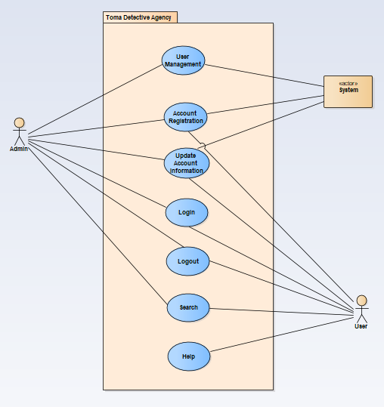

# 8.0 Appendices

Presents information that supplements the Requirements Specification

## 8.1 System traceability matrix

A matrix that traces stated software requirements back to the system specification.

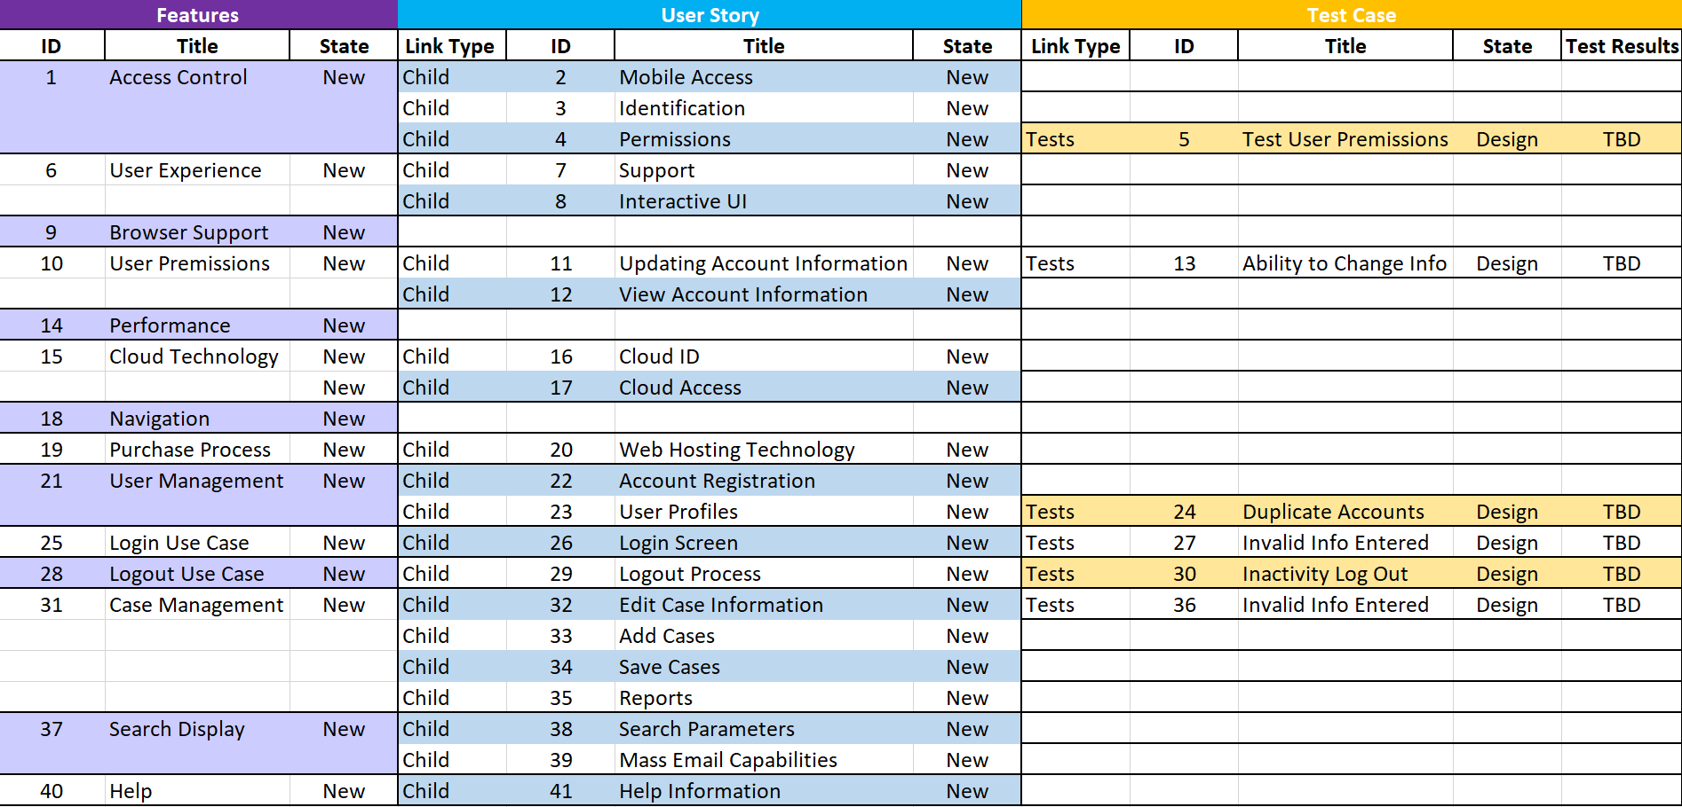

## 8.2 Product Strategies

If the specification is developed for a product, a description of relevant product strategy is presented here.

**User-Focused Design**: System users like admins and agents must have a user-friendly and easy-to-use interface so they don’t face any difficulties while performing a task. A survey could be an option to know what exactly a common user is expecting so the system can be developed according to the user’s perspective rather than they learn about it. However, the main purpose is to provide a better user experience.

**Data Security and Privacy:** As the nature of this software is very sensitive and it contains the data of different types like the stakeholder’s information such as admins, clients, and agents therefore the security of this system is one of the most crucial aspects. The system should meet security and protection standards and implement a reliable user authentication that has a secret encryption function to keep the passwords and protection keys safe.

**Remote Access and Cloud Deployment:** According to the requirements system must be available for users from any place and any system like computers or mobile phones so they can perform their tasks remotely. It should be a web-based system hosted on a cloud-based hosting and should have compatibility with all browsers and operating systems.

**Comprehensive Case Tracking**: The agent is one of the main stakeholders of the system, he should be able to add data about the new clients and cases. The system should provide the agent the facility to enter all the relevant details of the case so it must have all the fields in the related form for example case ID, media(images or video), and time and date. It should also have a functionality to search anything like case id or name of client or agent because if the user wants to track any case or client he should be able to do that.

**Reporting and Communication:** The feature of generating reports in pdf form also should be available for agents and they should be allowed to send these reports to clients and related authorities. To communicate with clients and marketing he should also be able to send bulk emails as well.

**Audit Logs and Admin Controls:** There should be also an admin of the system who has access to all the information and changes agents do in the system. Admin should be allowed to edit any case data and can view all the other details related to the changes and modifications. Admin should have all other controls for user management.

**Scalability and Performance:** The system must have the ability to deal with a large number of users. For example if users increase, the system should still work properly and there should be no effect on the performance and speed of the system.

**Documentation and Training**: To provide a better user experience there must be documentation for users to guide them on how to use the system and how they can perform their desired task. The system itself should be responsive so users don’t face any kind of difficulties in use.

**Continuous Improvement and Maintenance:** For the system's betterment and improvement there should be user feedback and in case of bugs and errors it also will help to improve system performance.

## 8.3 Analysis metrics to be used

A description of all analysis metrics to be used during the analysis activity is noted here.  
  
**User Adoption Rate:** To know about the system's acceptability we use the user adoption rate matrix because this is based on the number of sign-ups and signs on the system during a particular time frame. It’s directly proportional to the system's acceptability.

**User Engagement:** User engagement as it’s clear by its name that it’s about the user interaction on the system. We use this metric to calculate how much the system is useful for the users. Therefore if users are using the software more often and doing different activities like using different features of the system that means they are getting used to the system and it’s eventually benefiting them.

**System Performance**: To ensure the full use of the system it’s a must to keep check on system performance. For example, performing different activities like entering a new date or creating a new user system speed should be as per requirement. By this metric analysis, we can make our software more useful and efficient.

**Error Rate:** To improve the software every day and make it more efficient we need to reduce the bugs and errors in the system, that’s why we use this metric to solve the bugs in software. These errors may occur while performing different tasks using the software for example while tracking or creating a new case in the system.

**Search Efficiency:** It's one of the main features of this software because whenever a user would track a case or admin or other users want to see some information or data they will use the search functionality so it should work fast to fetch the information from the database and result should be accurate. Therefore to improve search results we make this metric and analyze the results.

**Security and Privacy:** Security is the one of the main aspects of the system so to ensure the protection of the data from unauthorized users and other malicious attacks we make this matrix to evaluate system capacity to ensure the security and privacy of the data. This metric also analyzes if the software security system meets the standards or not.

## 8.4 Supplementary information (as required)

**User Feedback:** To improve software quality and performance user feedback is very crucial because they are using it in an actual environment and can give a fair opinion about the performance and issues in the system. Surveys, interviews, and feedback forms can be good to gather user feedback about the system. They can highlight the good and bad areas where the system is performing as per requirement is having problems, and they also can send some recommendations to improve the system. Eventually, this will help to improve the system’s quality.

**User Demographics:** For a better understanding of the unique demands and preferences of users of the system it will be helpful to learn about the demographics of the end user. This will help to target the exact needs of a particular group of users. If some users are looking for some special features we can easily understand and will be able to help them by developing that.

**Training and Support Materials:** For better user experience this is the best idea to give the training and some helpful material that will help them to use the system and perform their specific tasks using this software. They could have a better idea about the software and its functionalities.

**System Usage Data:** Collecting data on system usage can provide valuable insights into user behavior and patterns. This data may include the frequency of logins, the most commonly used features, and the time spent on different tasks. Analyzing this information can help identify popular features, potential bottlenecks, or areas where users may need additional support.

Data on users’ interactions with the software and their activities is the best way to learn about user behavior. Based on mostly used features by specific users and how much time they spent on this system, we can sort out what are the areas we can focus on because those are functionalities mostly used by users and we can improve them.

**System Updates and Enhancements:** Changes according to the needs and feedback of the users must be kept on record because that is the record of how we have upgraded the system as per the end user’s needs.